Aerostat Control System
User Manual

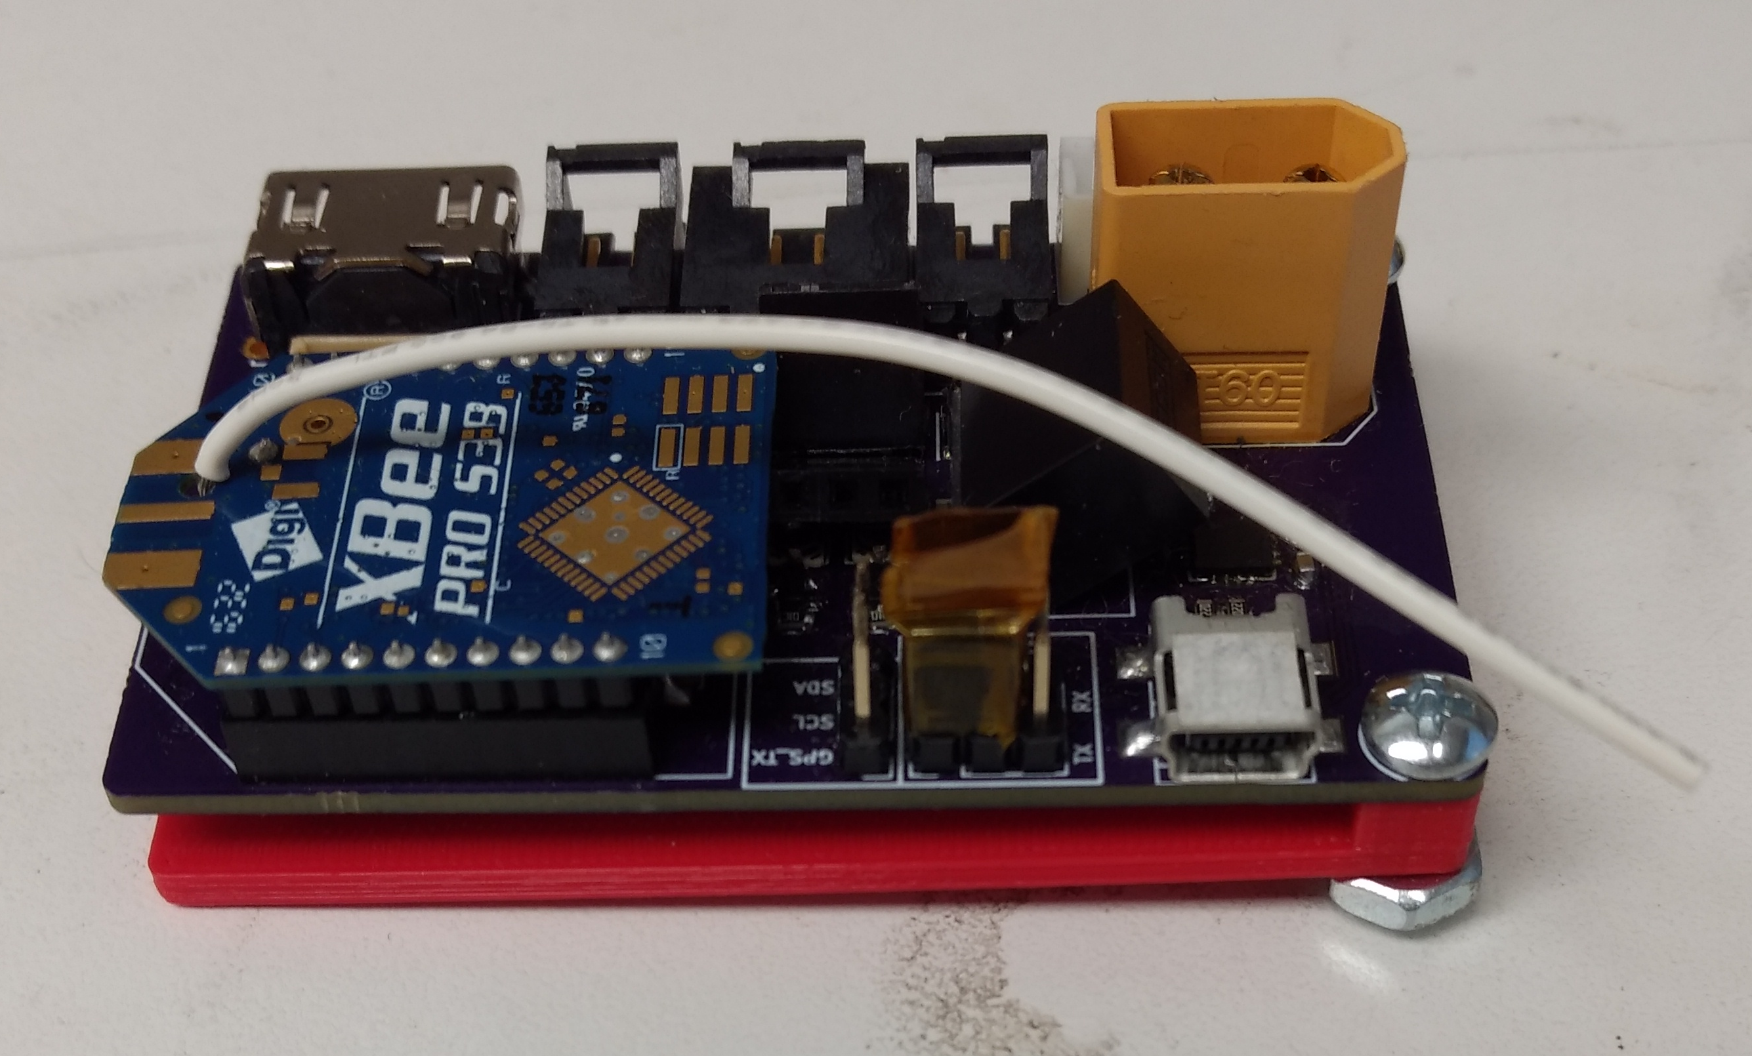

CDM 12-31-17
Table of Contents

Hardware Overview………………………………………………………………………………...3

Firmware Overview………………………………………………………………………..………10

Notes………………………………………………………………………………………………….11

Hardware Overview

The system consists of five parts. This parts include:

The main board:

RGB+3 Camera:
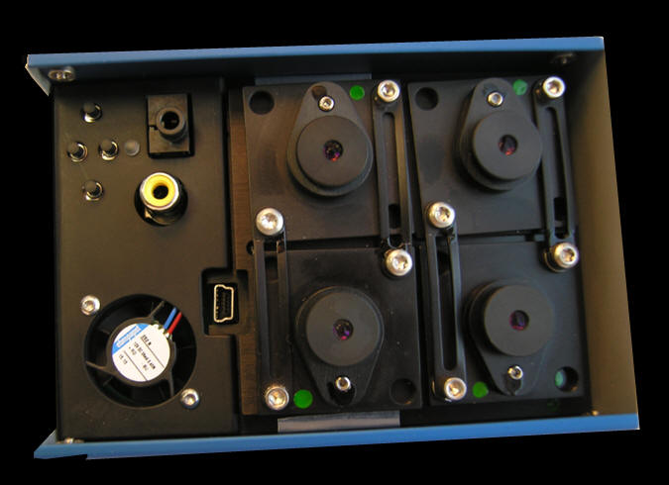

FPV Transmitter:
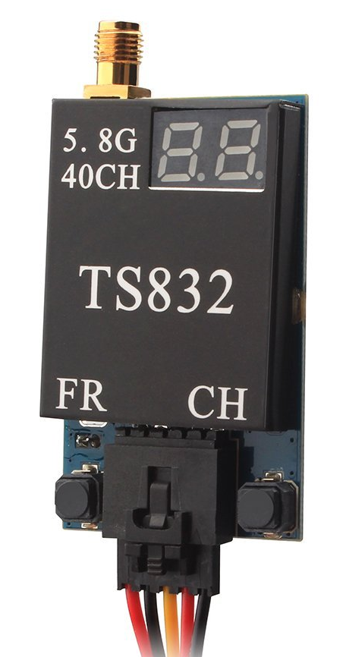

FPV Receiver:
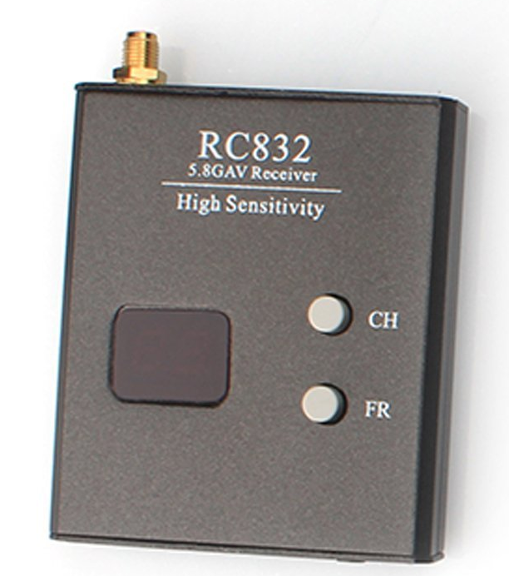

XBee USB Dongle:

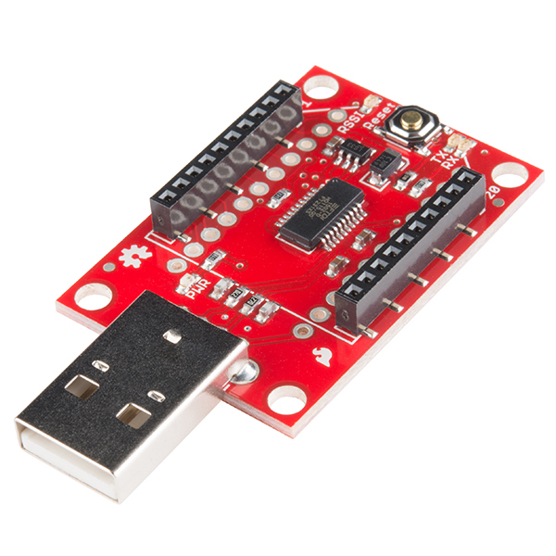

Main Board

The main board consists of a Printed Circuit Board (PCB) that was designed using KiCAD EDA. PCBs were ordered through OSH Park and hand assembled.

The board is designed to allow wireless control of the Tetracam RGB+3 Camera (discussed in next section). The board includes circuitry and components that utilize an XBee 900MHz Radio Module operating in pass through mode that connects to an ATMega328P (AVR) Microcontroller (MCU). The AVR runs a modified Arduino bootloader that normally runs on the Sparkfun Pro Mini 8MHz model development board. The Optiboot bootloader allows the AVR to be programmed over USB through an FTDI FT230X USB to UART serial bridge. This function is identical to most Arduino boards that do not have native USB functionality on the MCU itself. The AVR also communicates with the on board XBee module over UART serial. Since the AVR only has one hardware UART serial port, on REV C of the board, jumpers wire included to allow selecting between connecting the AVR to the FT230X bridge or the XBee module. This allows the AVR to use hardware UART serial to communicate where it matters. In REV D of the board, a multiplexer (MUX) is used to switch between connecting to the XBee and the FT230X bridge. The control signal for the MUX is the +5VDC line on the USB connector. Therefore as long as the board is plugged into a PC over USB, the board will connect the AVR to the FT230X bridge automatically.

In REV C of the main board, the GP-735T GPS module connected to the AVR using the Arduino firmware Serial library. This allows the AVR to know its geographic position. The GPS also connects to the RGB+3 Camera. REV C did not include the necessary UART To RS232 Adapter that the RGB+3 requires. As a result of this, an external adapter was spliced into the system to make due. REV D (in progress) does include the adapter on the board itself to allow for a more compact system. The adapter used is the Maxim Semiconductor MAX3232 which runs off the logic level (+3.3VDC) of the rest of the board but is able of generating the larger voltage swings required for RS232 communication.

Modified GPS Dongle:
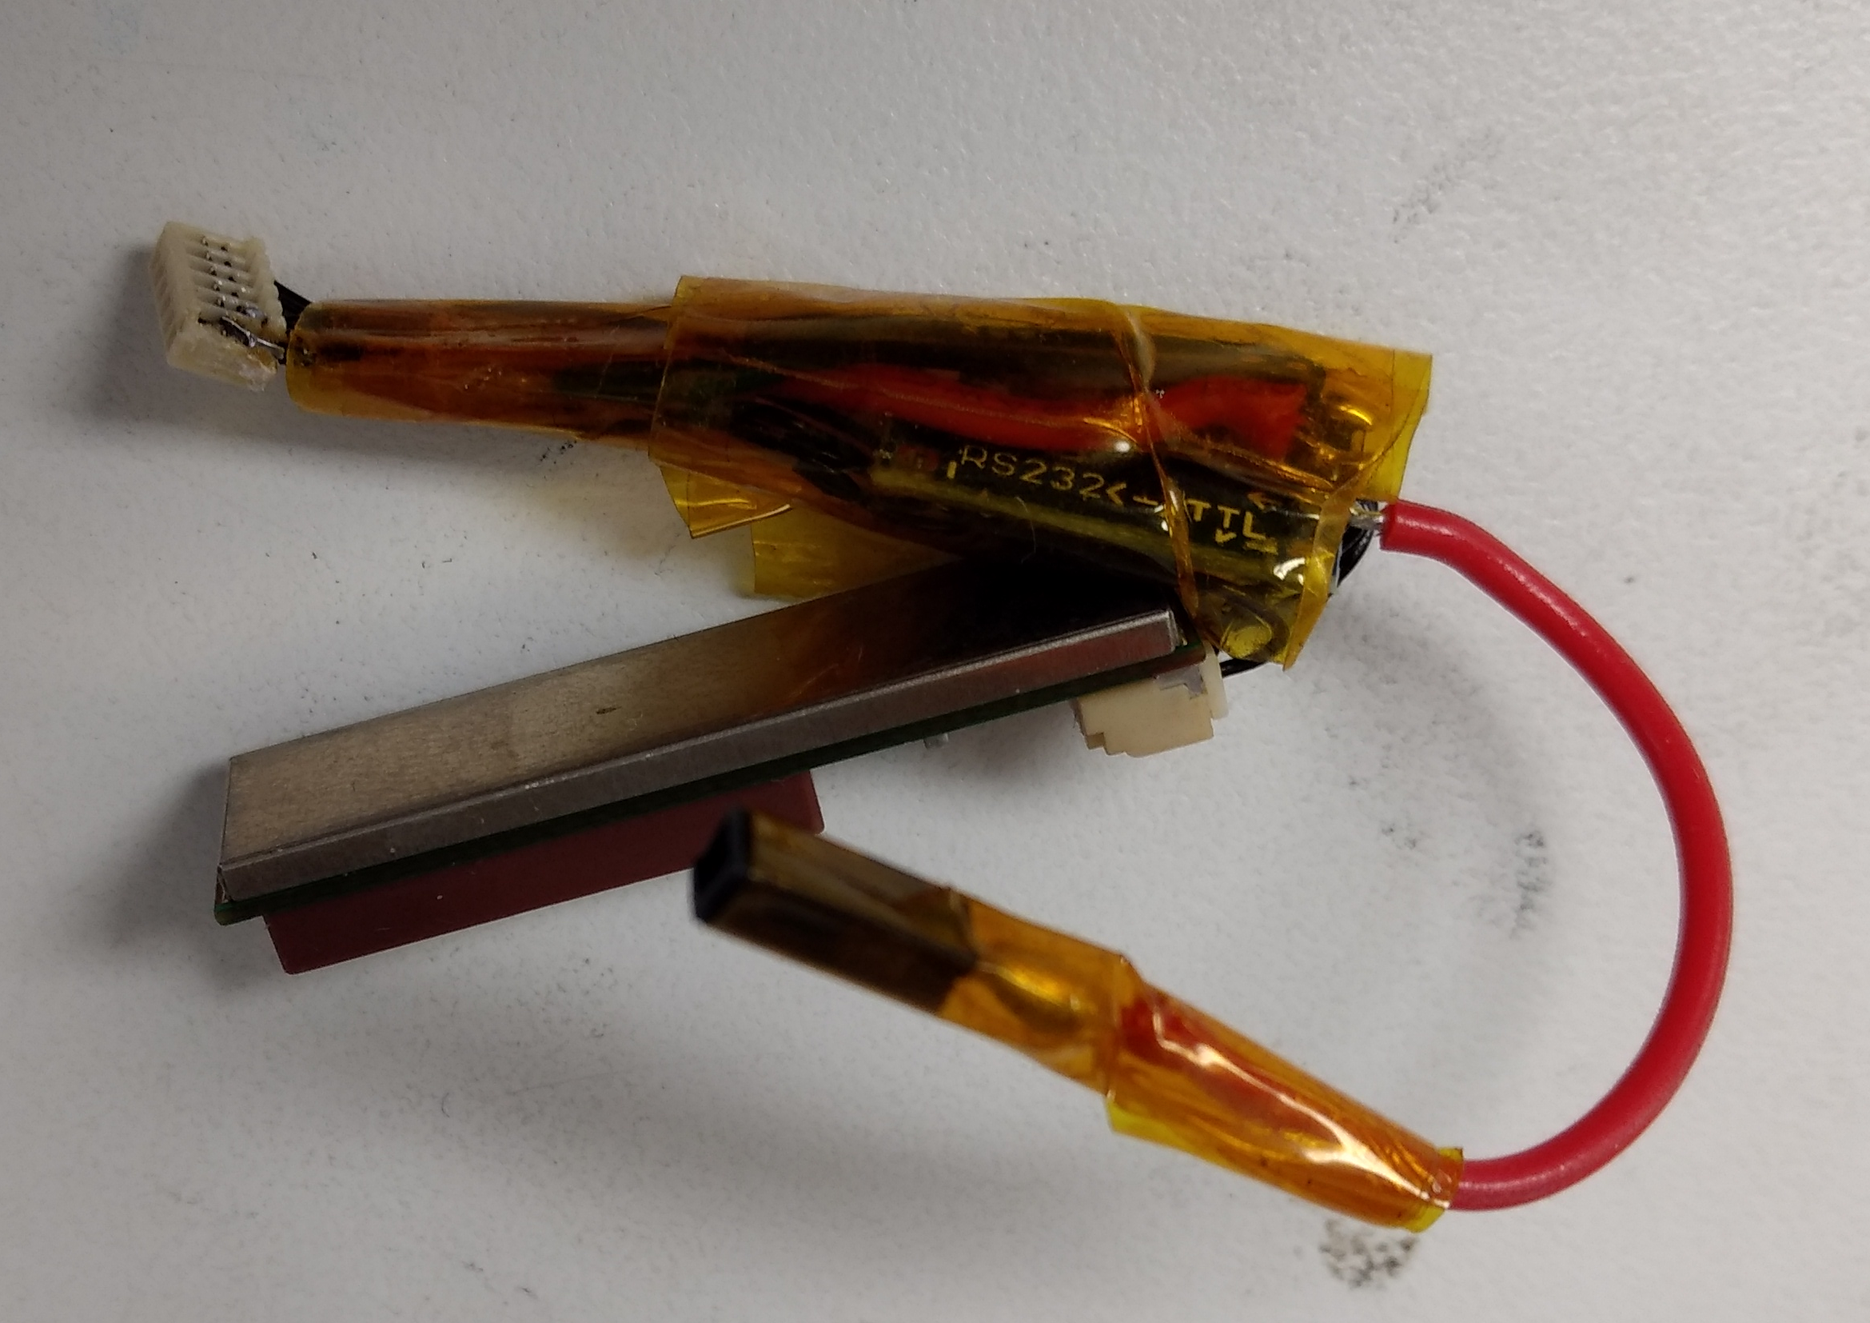

Modified GPS installed on PCB:
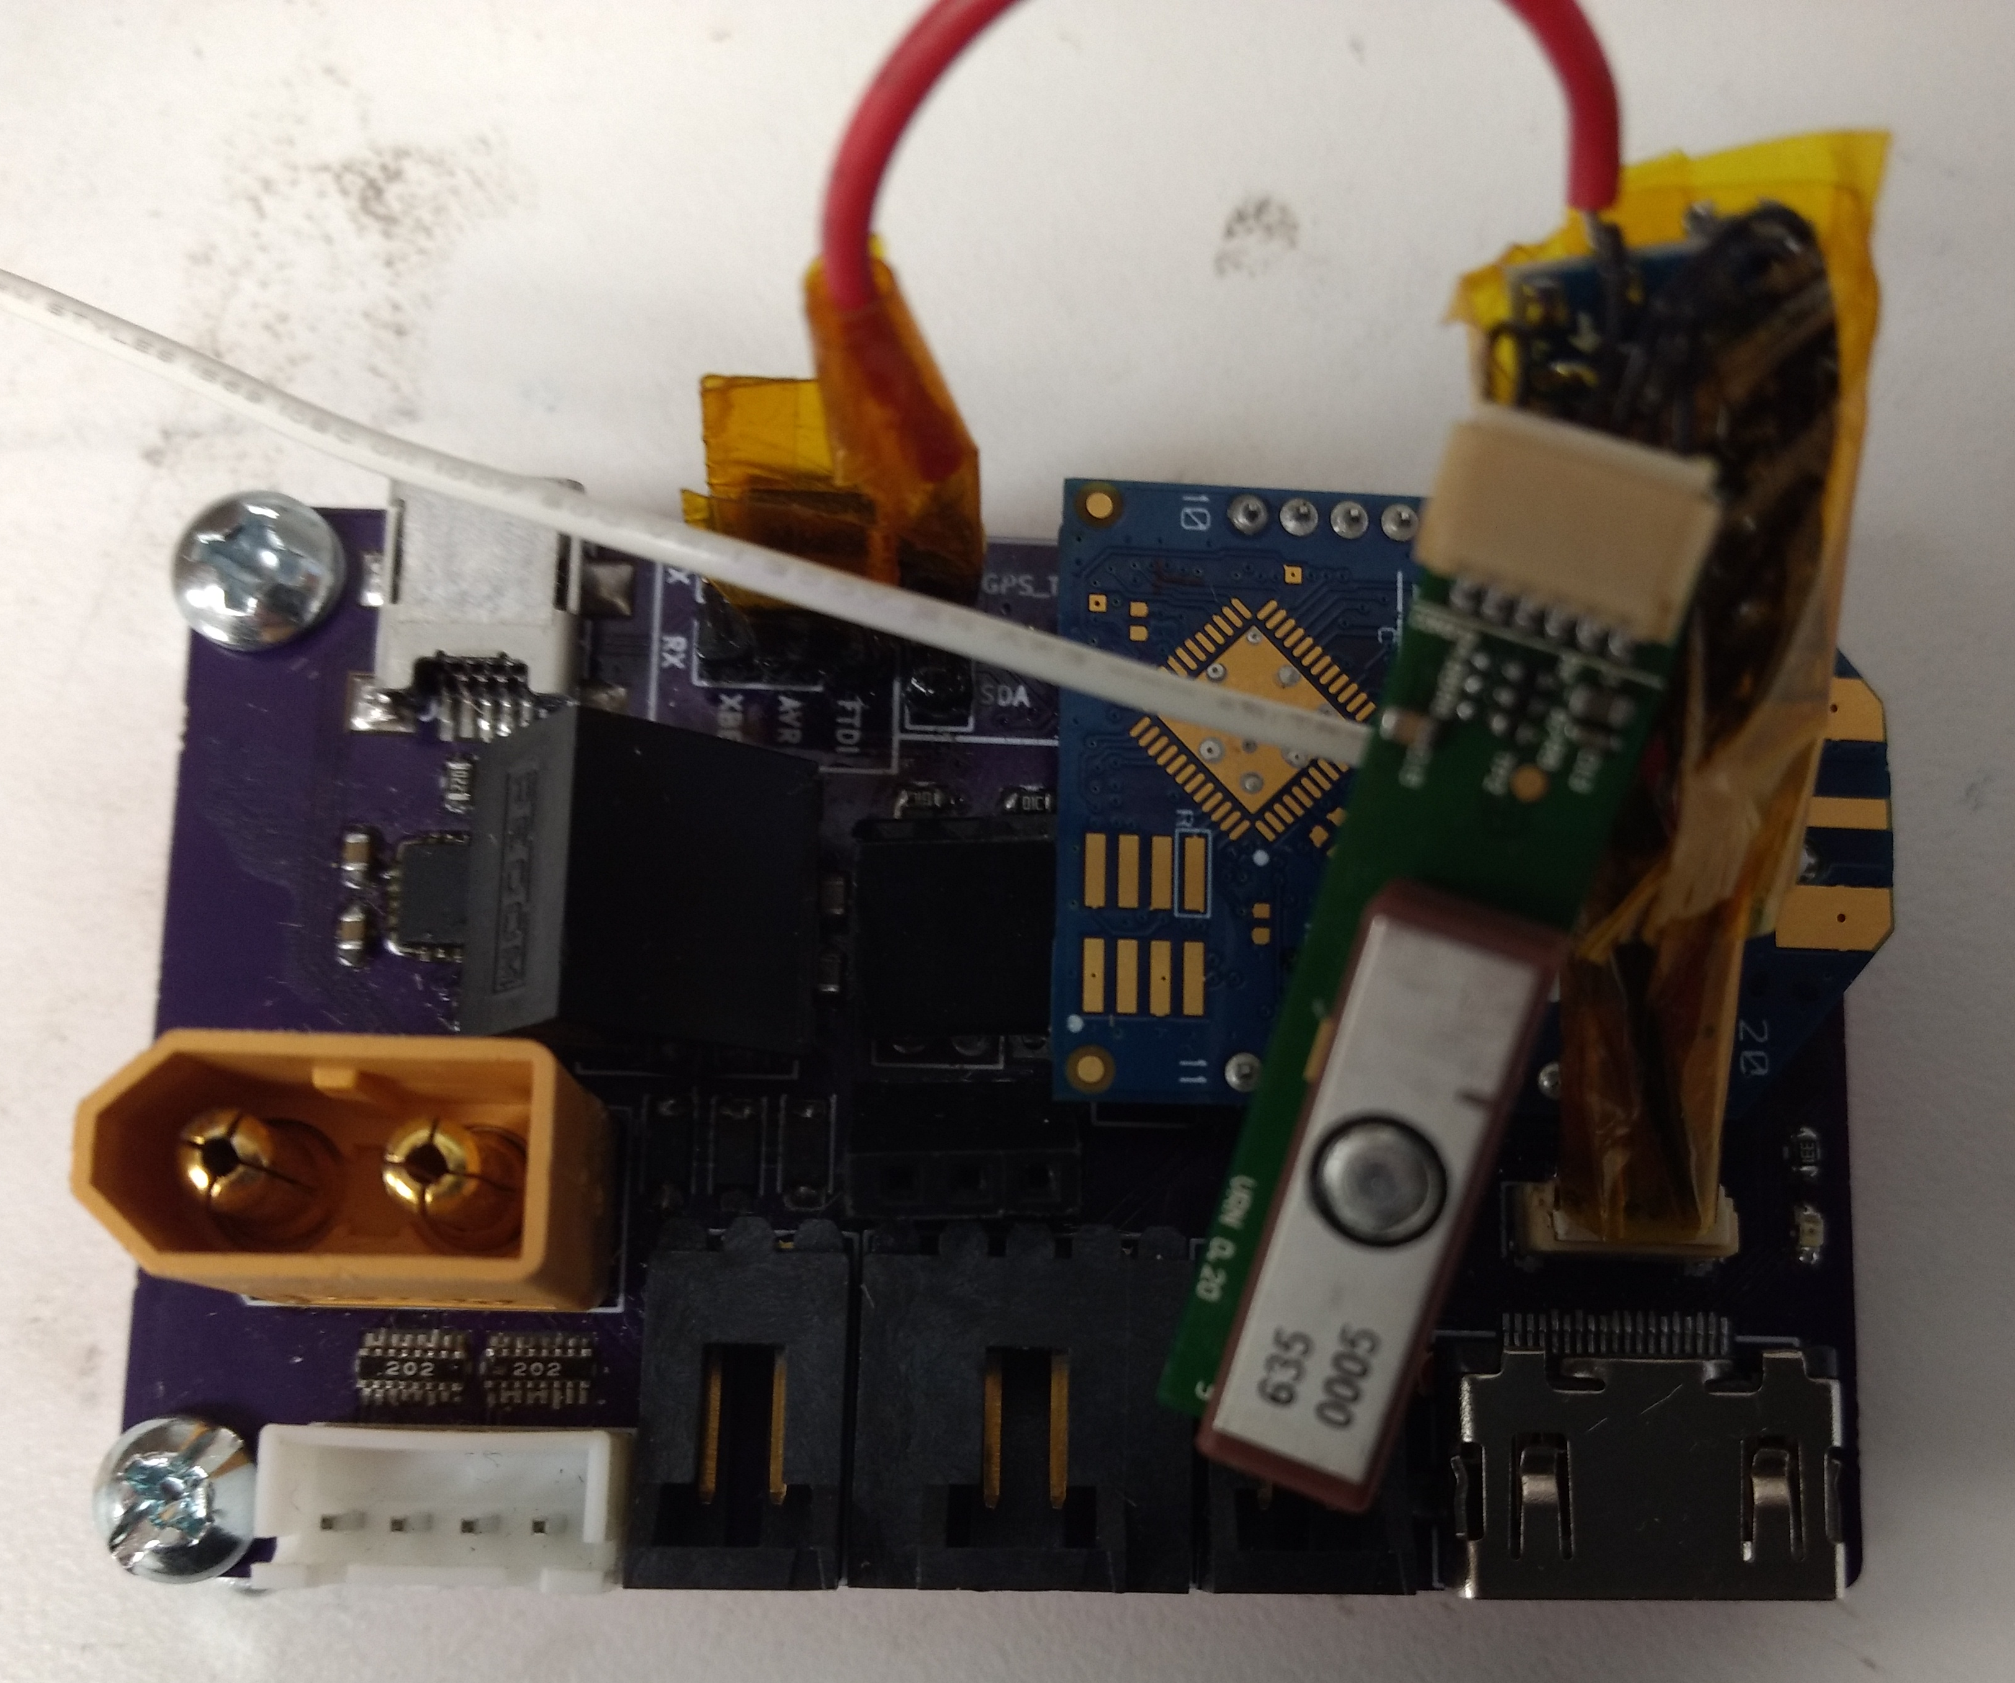

Input voltage from USB is +5VDC and is regulated to +3.3VDC using the Recom R-78 buck regulator module (+3.3VDC, 500mA). Previously (REV A & REV B) used a self designed voltage regulator module that utilized the Semtech TS30011 buck regulator. Stability issues on both designs of the regulator module. Both regulators are highly efficient buck regulators. The current Recom R-78 is a through hole module that allows use of a common linear +3.3VDC regulator such as the ST Microelectronics LD1117V33 if the Recom R-78 module is to fail or not work appropriately.

REV C included over voltage protection circuitry using a crowbar type configuration. This was because of the failed design of the voltage regulator modules. The crowbar circuits were arranged on the input 3 Cell 11.1V Lithium Polymer Battery (3S LIPO) into the board and the output of the 3.3V regulator module. On REV C, the crowbar circuits were tested to be working but since the triacs in the circuit were removable, the circuits were ran without the crowbars operation for some time. No ill effects were observed so for the sake of simplicity, the crowbar circuits were removed in REV D.

Please refer to the schematics for further information on the main board.

RGB+3 Camera

The Tetracam RGB+3 Camera is a multi spectral camera designed for use on aircraft. The camera interfaces with the main board over a standard HDMI cable. This cable can further be referred to as the Multi-GPO (General Purpose Input Output) cable. Tetracam set forth standard connections for the system. Most of these connections are standard inputs or outputs at a +3.3VDC logic level with the exception of the RS232 port that connects to the GPS. Additionally, the camera includes NTSC video over the HDMI connector as well. Beware, the HDMI does not have a standard HDMI pinout! Connecting the camera to another device over the HDMI cable is not recommended! The main board mentioned above includes the necessary connections to an First Person View (FPV) transmitter and GPS module with RS232 level shifter. The RS323 port is accessible additionally through a 3.5mm auxiallaty jack on the camera. The NTSC video stream is accessible additionally through an RCA plug on the camera.

Tetracam supplied a key shaped PCB that has a HDMI connector on one end and breakouts the different signals of the HDMI cable.

Please refer to the RGB+3 User Guide from Tetracam for more information on the camera.

FPV Transmitter

For simplicity’s sake, an external FPV transmitter was utilized, the FPV transmitter model number is the TS832 module. This module supports multiple different modules and is interfaced via a 5 pin connector.

FPV Receiver

The matching receiver for the chosen transmitter is the one included in this project. The chosen receiver’s model number is the RC832 module. This module also supports the same channels as the FPV transmitter. Normally, the FPV receiver outputs video onto an RCA type plug but this receiver was modified to include a USB video capture card. This means that the receiver can be directly plugged into a PC over USB type A in which the device acts as a standard web cam. The device is also powered over the +5VDC from the USB cable. On Debian Linux, the camera is recognized however on Windows, drivers may need to be installed. In this case, the drivers required are the USBTV007 driver.

Proper setup will yield the boot logo as seen below:
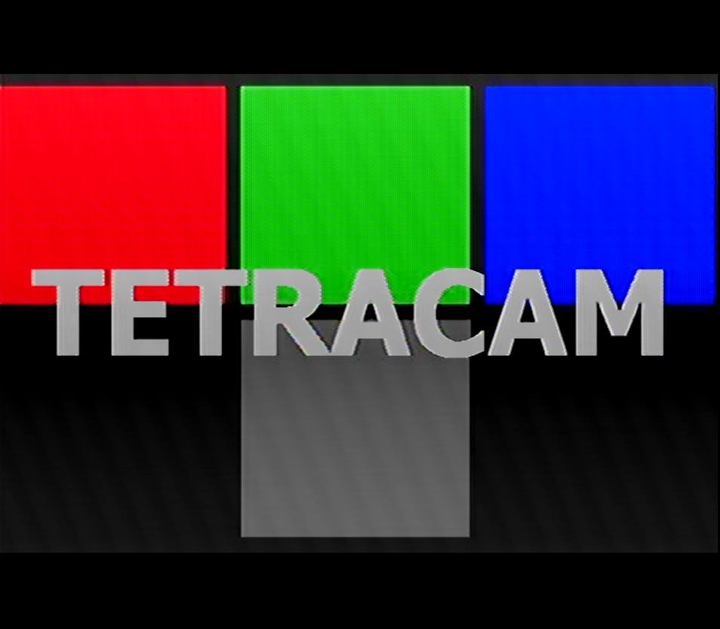

XBee USB Dongle

The XBee USB dongle from Sparkfun allows a simple connection between the XBee and the PC. The XBees chosen are the XBee Pro 900 model with wire whip antenna. These have been tested to about 1000ft successfully. Currently the XBees are configured to run at 9600 Baud. To interface with the XBee, a COM port program needs to be installed on the host PC. For Windows, a suitable program is PuTTY. On Linux, a suitable program is CuteCom. Command processing on the main board expects to NOT see line end characters, therefore set the line ending to NONE in both programs to reliably communicate with the main board.

Entering a ‘h’ into the COM port program should yield the “Commands” menu:
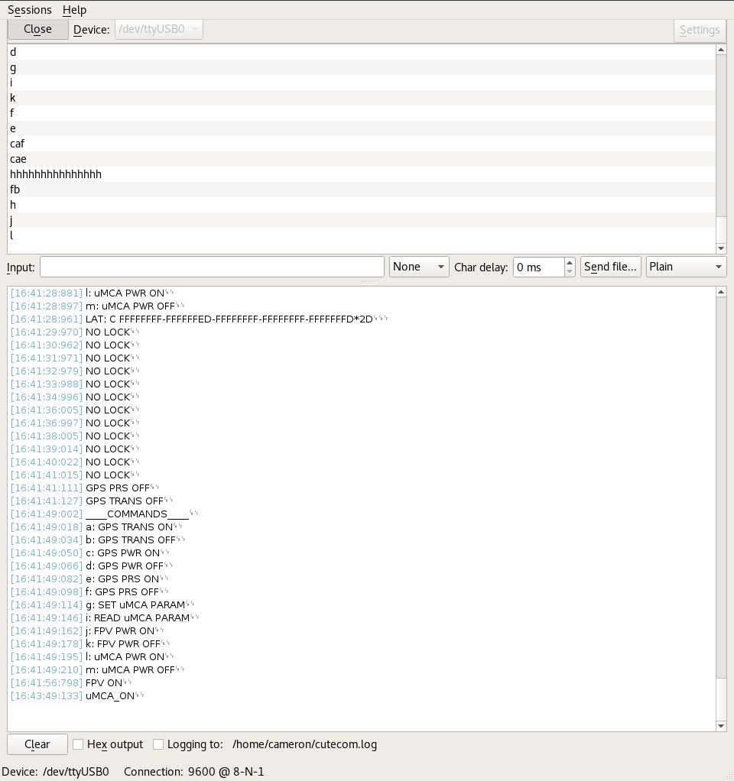

Firmware Overview

The code for this system was originally designed to run on a Raspberry Pi Zero W and ATMega328P running the Arduino bootloader. As such, the code was first written so that the Pi could be powered down and awaken using the AVR. The two MCU communicated over the I2C bus. The initial plan was to use the Pi as a USB host for the RGB+3 camera and transmit the collected images via the XBee to the ground based XBee. This proved needlessly complex for our purposes, so the idea was never implemented. Because of this, the Raspberry Pi was no longer needed, so it was removed from the design. This simplified the firmware because the AVR no longer needed to receive commands from the Pi.

Currently the firmware is able to wireless manipulate the camera to take pictures. The picture taking is automated via settings that are recorded on the EEPROM of the AVR. The firmware puts the camera to sleep when the camera is not active to conserve power.

Occasionally the camera enters a diagnostic mode on boot. In this mode it is impossible to take a picture. The camera has an on board LED that is either red or green indicating the status of the camera. These signals are broken out onto the Multi-GPIO cable and Tetracam refers to these signals as LED RED and LED GREEN. Under the condition that the camera is turned on but the camera is indicating that it is busy, the firmware will navigate through the menus on the camera to exit the diagnostic mode.

Diagnostic Mode:

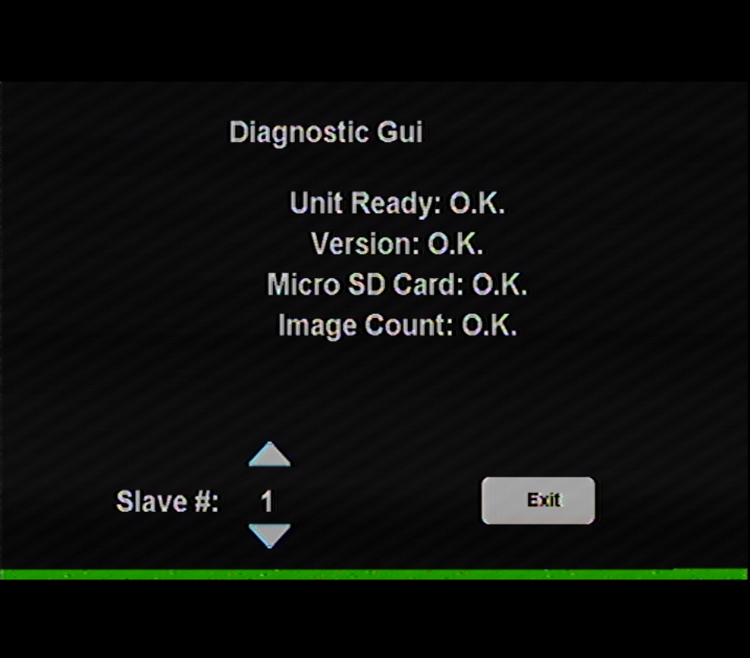

Notes

- Do not plug the PCB into any other HDMI device other than the RGB+3
- The firmware needs to be updated to turn the GPS on when the camera is turned on
- Be sure to select NONE as the line ending when interfacing with the PCB
- When writing firmware be sure to configure a pin as an output before writing to it
- Send ‘h’ through the COM port to see the help menu on the PCB
- Send ‘x’ to manually take a picture
- LIPO batteries are dangerous if they are depleted too far. The PCB includes a 3S LIPO balance connector however at this point, a low battery cutoff has not been implemented in the firmware.

